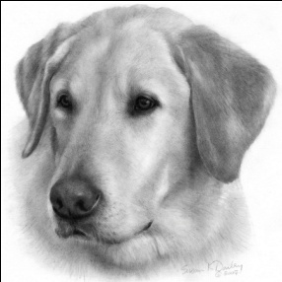
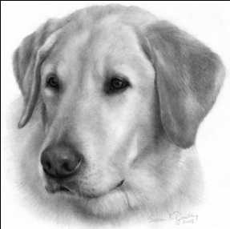
Wright Way Retrievers
BILL OF SALE
Kasey Wright
10026 FM 512
Wolfe City, TX 75496
(510) 685-7535
wrightwayretrievers@hotmail.com
www.wrightwayretrievers.com

SIRE: Washita’s On The Warpath SH DN AKC# SR91949710

DAM: Beck’s Really Sterling Lexus “Lexi” AKC# SR82887606

BREED: “Labrador Retriever”
SEX: Male/Female
COLOR: Black/Yellow/Chocolate

COLLAR COLOR: ____________________ AKC #: ______________________

PURCHASE PRICE: ___$1000.00____ MICROCHIP #: ________________________

PURCHASER(S): _________________________________________ __________________________________________

ADDRESS: __________________________________________

CITY, STATE, ZIP: __________________________________________

PHONE # __________________________________________

EMAIL: __________________________________________

DEPOSIT PAID: ___$200.00____ DATE: _______________

BALANCE PAID: ___$1000.00____ DATE: _______________

PUPPY READY TO GO HOME ON: ________________________

Purchaser must make their litter pick no later than week seven. If pick is not made by week seven your pick will be forfeited to the next person.

Note: Wright Way Retrievers has the option of first pick of the litter at any time of male or female.

Buyer's intentions for this puppy include:

Pet/Companion _____ Hunting _____ Field Trials and/or Hunt Tests _____ Pet Therapy/Service Dog _____

If other, list __________________________________________

Deposits are non-refundable. The Seller will provide a 26 month HIP and EYE GUARANTEE at the time of sale. Seller makes no guarantee on the physical characteristics of these puppies. Puppies come with 1st Core Vaccinations, de-wormed, micro-chipped and AKC registered.

Pups must be checked by their own vet within 5 days of going to their new home. It is impossible to state that a puppy will be completely free of genetic imperfections. In our breeding program, we only breed females with an OFA rating of GOOD or EXCELLENT and EYE rating of NORMAL, to males certified with an OFA rating of GOOD or EXCELLENT and EYE rating of NORMAL. We feel that by adhering to these standards, we are reducing the risk of producing a defective pup or litter. Therefore, we offer this HIP and EYE guarantee, providing that the buyer complies with this agreement. No other conditions apply to this contract.
**PLEASE VIEW HEALTH GUARANTEE ATTACHED FOR MORE DETAILED DISCRIPTION**
Puppies will only be held past the date of eight (8) weeks of age by prior arrangement. Seller may sell any puppy held past the date of nine (9) weeks of age (unless prior arrangement has been made) with Buyer forfeiting deposit and all claims to the puppy. If puppy has been paid in full, seller will return the purchase price, minus the deposit. Any expenses incurred by Seller shall be deducted from any returned monies owed to Buyer.

Buyer must sign and return one copy to Wright Way Retrievers.
Before a puppy is 12 weeks of age, the Buyer agrees to have microchip registered in their name through AKC ReUnite with Wright Way Retrievers being listed as 2nd contact (optional). This will help us insure the safety of the puppy. Registration fee of $17.50 is the buyer’s responsibility.

By completing this document you are agreeing to the following:
- The purchase of the above stated puppy.
- To pay the balance in full when picking up your puppy if you haven’t already done so.
- To pick up your puppy no later than one week after the date stating when the puppy is ready to go home, unless other arrangements are agreed upon.

What you can expect to receive by completing this document:
- A healthy AKC registered Labrador Retriever puppy.
- Bill of Sale, 26 Month Health Guarantee, Puppy Folder containing all necessary documents and vaccine record.
- AKC registered with full registration rights.

The Buyer has read, understands and agrees to the terms of the above stated contract with “Wright Way Retrievers”.

_____________________________________________________ __________________________
_____________________________________________________ __________________________
Breeder(s) Signature Date

_____________________________________________________ __________________________
_____________________________________________________ __________________________
Buyer(s) Signature Date

